|  |
| --- |
| Close-up image showing the leaf-sides of two oversized books side-by-side on a bookshelf, with additional books in soft focus background |
| [LED FLASHER] |
| |  |  |  | | --- | --- | --- | | Swarup Deb | 11/3/19 | 19BCG1077 | |

***CIRCUIT DIAGRAM*** 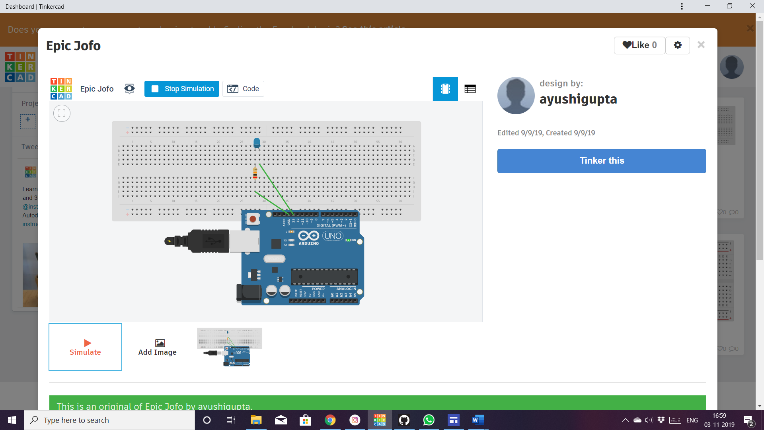

**THEORY**

Concept used:

Basic knowledge of circuits is necessary which includes the proper connection of led, resistor, breadboard & Arduino.

LED flashers are semiconductor integrated circuits used to turn on and off groups of light emitting diodes either sequentially or according to a programmed pattern. They are found in circuits used as indicators and controllers, as well as in home-built projects.

LED series and parallel circuit :

Although the LED series chain has the same current flowing through it, the series voltage-drop across the needs to be considered when calculating the required resistance of the current limiting resistor. The combination in parallel has same voltage flowing through it and the current divides within the circuit.

Also, the concept of breadboard must be known in order to make an effective circuit and to avoid conceptual mistakes, the interconnections of breadboard are to be known.

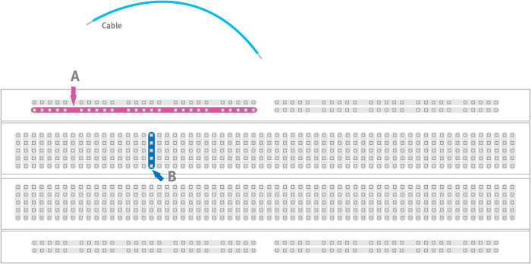

The breadboard is considered into two halves, laterally. In the first half; first 25 dots of first row are connected to each other followed by next 25dots of first row are connected together, the case is similar with the second row also. Below in the bread board a column of 4dots are connected to each other and similarly the connection is column wise and no column is inter-connected.The same is with the second half.

**OHM’S LAW:**

**Ohm's law** states that the current through the conductor between two

points is directly proportional to the voltage across the two points at

constant temperature.

{\displaystyle I={\frac {V}{R}},}V=IR

where *I* is the current through the conductor in units of ampere, *V* is

the voltage measured *across* the conductor in units of volts, and *R* is

the resistance of the conductor in units of ohms. More specifically,

Ohm's law states that the *R* in this relation is constant, independent

of the current.

It cannot be applied to non-linear devices.

It also cannot be applied when the temperature keeps on varying.

**KCL: Kirchoff’s current law**

The law states that for a parallel path the total current entering the circuit junction is exactly equal to the total current leaving the circuit junction at the same junction.

All the currents entering and leaving a junction must be equal to zero as

Sum of all the currents entering at the junction=sum of all the currents leaving the junction.

**KVL:Kirchhoff’s voltage law**

The law states that for a closed loop of series path the algebraic sum of all the voltages around any closed loop in a circuit is equal to zero.

All the voltages entering and leaving a junction must be equal to zero as

Sum of all the voltages entering at the junction = sum of all the voltages leaving the junction.

***LEARNING AND OBSERVATIONS:***

1.Learning the process of dealing with hardware and software.

2.Theoritical and practical application of ohm’s law, KCL, KVL and other theories.

3.Learning the process of making circuits.

4.Learning to glow LED chasers in different sequences.

5.The LED glows only when the anode is connected to the ground and the cathode is connected to any on the pins ranging from 2 to 13

6.The LED doesn’t glow if heavy resistance is attached to it.

7.Checking for proper series and parallel connection.

8.The LEDs’ glows in a chasing pattern upon the simulation of code.

***PROBLEMS AND TROUBLESHOOTING***

1.Connections of LED may not be connected properly.

2.LED may not glow as the LED’S may not be working, so checking for the LED’s are in working condition before making the circuit.

3.The dis-functioning of the circuit may be also be a result of shot wires, check if the wires are in proper condition.

4.Code may also be wrong, checking for logical errors and syntax errors in the code and subjecting it to proper editions.

5.Arduino may be not be working.

6.All connections should be checked properly.

7.All the apparatus should be in working condition.

8.Use the right code.

9.Check for right options selected in the software before uploading the program to the Arduino.

10.To check if the resistors of required resistance are connected in the circuit; more or less resistance in the circuit may result in dis-functioning of the circuit or may cause harm to the connected apparatus.

***PRECAUTIONS***

1.Do not place an LED without attaching a current limiting resistor because too much of direct current flow in the LED may result in damage to the LED.

2.Do not supply more than 9V to LED.

3.Do not attach the battery to the circuit without proper knowledge of it, it may cause damage to the circuit.